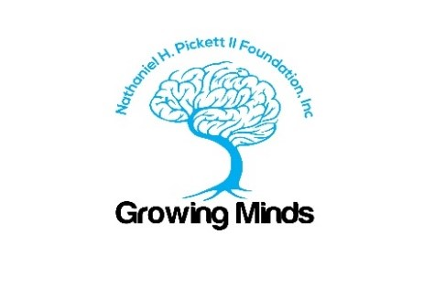

Virtual Student Film and Production Internship/Scholarship
Part time with a community service-oriented non-profit

The Nathaniel H. Pickett II Foundation has an opportunity for a student Film and Production
Intern. You will represent the company and work with the management team to film, edit and produce videos and other digital content for social change.

The Nathaniel H. Pickett II Foundation (NHPII) is 501 (C) (3) focused on social justice and change in the areas of: mental and physical health, mass incarceration, violence reduction, community and law enforcement relations. The foundation is based in Las Vegas, NV and its goal is to educate and serve the community.

You will gain hands-on experience filming, creating/editing videos, and assisting with the planning and execution of a nonprofit’s communications programming, such as blogs, social media marketing, design, media outreach, and more.

Are you an aspiring communications and marketing professional? Are you a student interested in building your skills and experience through a PAID internship? We would love to meet you to find out more about you and your awesome skills, and to see if our small organization, diverse team and culture is a good match.

Areas of Learning and Responsibilities may include but are not limited to:
- Research and develop story ideas across various subject matters and potential use scenarios, including social justice, mental health, community relations and institutional marketing.
- Turn internal client briefs/requests into action items.
- Oversee story components (video, audio, and written) through every step of the preproduction, production, and post-production process, including:
  - Draft treatments and shooting scripts.
  - Videography and photography
  - Collaborate with in-house and external production teams to guarantee the success of shoots.
  - Find music, source assets, write two- and three-column scripts, and provide direction to editors to ensure the final product is consistent with the original vision and is delivered on time.
- Maximize the use of websites and social media.
- Document progress of projects
- Monitor budgets and expenditures
- Develop and maintain relationships with internal partners to advise on content produced by the team.
Skills and Experience:
- Experience producing and writing for different video styles, including news-style segments, live segments, promotional videos, interviews, documentary-style segments, social media and motion graphics.
- Ability to edit videos.
- Prefer candidate have experience working in house with a creative service department.
- Basic knowledge and interest in social justice, mental health, and other issues impacting communities.
- Knowledge of working with motion graphic templates a plus
- Ability to work well under tight deadlines.
- Communication and interpersonal skills
- Confident in managing multiple projects simultaneously.
- Excellent written and verbal communication skills, with the ability to distill and convey information clearly and concisely.
- Detail-oriented with a can-do, roll-up-your-sleeves attitude
- Excellent time management and organization skills, yet comfortable with priority changes
- High level of professionalism and outstanding work ethic

Ideal Candidate:
Undergraduate student or graduate student with a background in film and video production. However, hands on experience will be favorably considered. High school students or high school graduates with proven capabilities. GPA 2.95 or higher.

Hours and Stipend:
Virtual meeting attendance is expected however, production hours are flexible. Success is based on project completion. Compensation is $350 for 20-25hrs per month. Students enrolled in a college, university or paid private high school will receive an additional $100 in scholarship funds paid directly to the school. Interns may negotiate school credit on a case-by-case basis. This position also includes paid travel opportunities and may include other professional courses as a benefit.

Application Process:
Send a cover letter, a resume and a one-page writing sample via email to info@nhp2foundation.org with “Communications and Marketing Intern” in the subject line. Applications will be taken, and interviews will be conducted until the internship is filled.

This is not to be construed as employment with the NHP2 Foundation. Interns can and will be released and scholarships can and will be terminated for non-performance or inappropriate behavior. Interested interns may be required to reapply and compete for the position. Students may also be able to coordinate college credit for the internship.

